**PESC CDS Task Force**

**Process Diagram Notes**

*For the Diagrams ‘Push w PaymentProvider’ and ‘Request w PaymentProvider’*

**Working Assumptions**

1. The requesting party should not be charged for requests that can’t be fulfilled.

*(e.g. record doesn’t exist or record on hold)*

1. Either a vendor agreement or a pre-approved debit account must be in place in order to proceed with transactions requiring payment.
2. The agreement token may represent either an institution or the vendor acting on its behalf

*(e.g. vendor could provide all of its clients with the same agreement token)*

1. The agreement token is provided by the paying party

*(But may be verified by the vendor receiving the token – e.g. does it make sense for this token to come from this source).*

**Cases Covered:** Document Push where

1. Transaction payment is not required
2. transaction payment is required
   1. an agreement is in place for pre-approved charges via
      1. transactional debit or
      2. vendor agreement recorded for future billing
   2. an agreement is not in place (request rejected – pre-approved payment required)

Figure - Push w PaymentProvider’

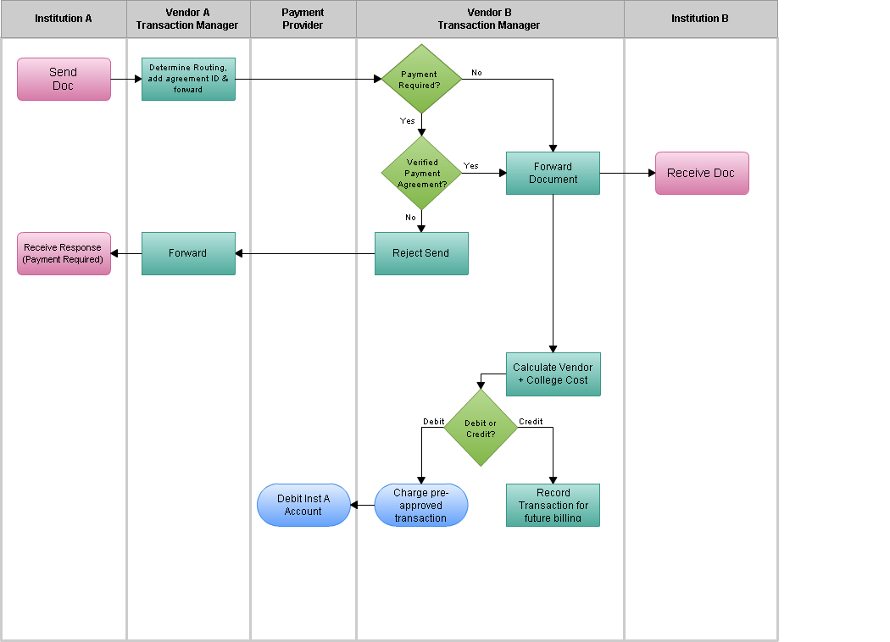

Cases Covered: Document Request where

1. Transaction payment is not required
2. transaction payment is required
   1. an agreement is in place for pre-approved charges via
      1. transactional debit or
      2. vendor agreement recorded for future billing
   2. an agreement is not in place (request rejected – pre-approved payment required)
   3. the requested document cannot be delivered (due to a record not found or record being held)

Figure - Request w Payment Provider

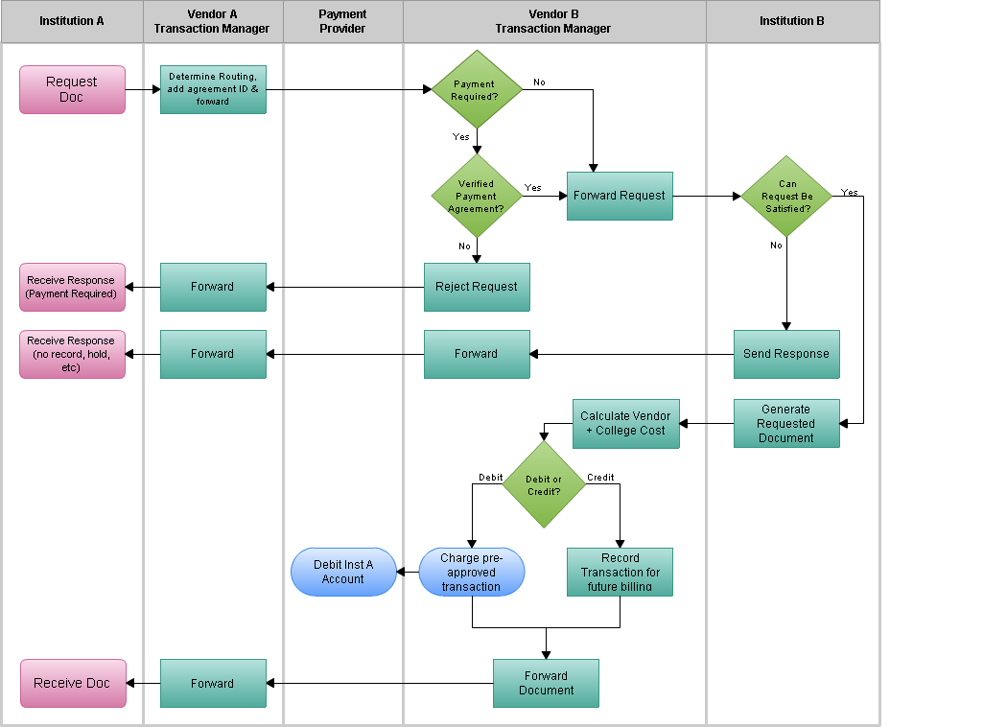

**Cases not covered**

1. Payments by an institution to the vendor acting on their behalf (eg. Institution A and Vendor A)
2. Interactive transactions where
   1. The requestor is redirected to a payment provider to establish a pre-approved payment agreement and then returned to Vendor B CDS Transaction Management system to continue the transaction with the newly acquired agreement token.
   2. The requestor is provided with a payment option such as credit card payment or paypal payment.